Introduction and background information
“Turn tragedy into triumph” said David Attenborough in COP26.
Global warming has become a hot topic in recent years. Climate crisis connected to many other problems like urbanization, population growth, resource scarcity, globalized economy, and other megatrends. These can be called wicked problems because there is not an easy answer to them. A good approach is to get future skills: creativity, problem solving skills, communication skills, co-operation skills. At the same time, there has been another crisis in complete silence, the severity and urgency of which is at least as great as that of global warming: biodiversity loss. Without a diverse nature, there is no human being - at least not a very well-being one.
Ninety per cent of biodiversity loss is caused by the way we extract and process materials, fuels, and food in a linear economy. We designed that economy. The good news is that we can also redesign it, and the circular economy provides some of the most effective tools, y tackling the root causes of biodiversity loss and getting more value from what we have.
But we need future skills to tackle the problems and active citizens to influence decision makers. All these elements are present in this course. Working days will be most practical, there will be lot of exercises, which are all suitable to the schools.
This course in Lapland will pay extra attention to the sustainable lifestyle and original culture among people living in northern areas.
Let’s follow Attenborough’s footsteps!

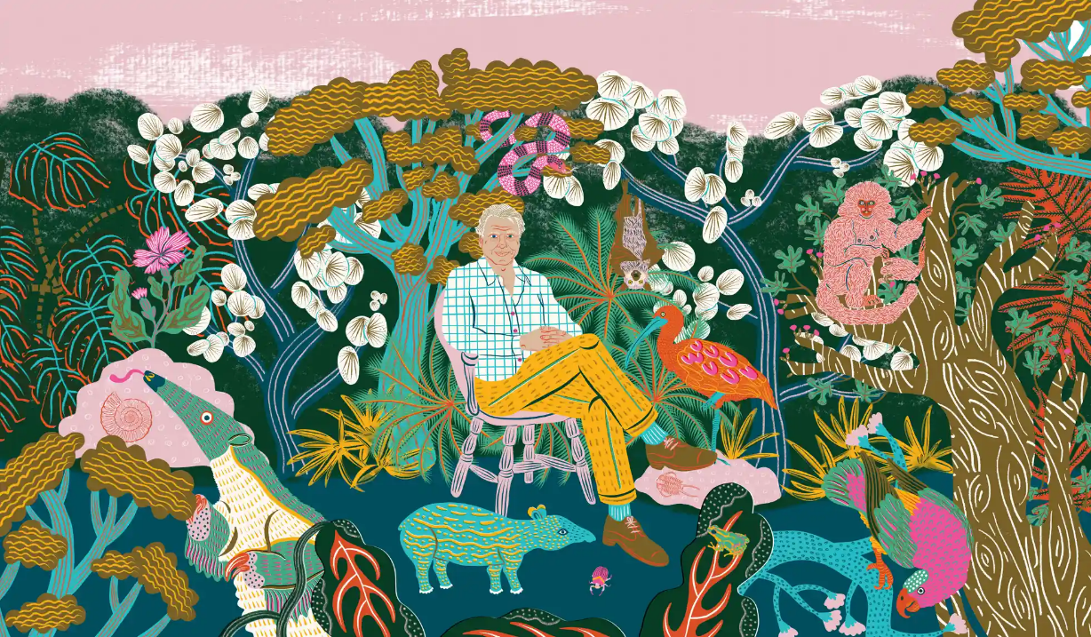

Program outlines of the course (changes are possible) 4.-10.6.2023.

Venue: Hotel Kultahippu, Petsamontie 1, 99800 Ivalo, +358405060682
Trainer: Tuovi Ronkainen

SUNDAY: Welcoming evening

17.00 Welcome and getting to know the surroundings and timetables and practices.
- presenting the program briefly
- setting the course objectives and outcomes
- getting to know each other and your personal story.

19.00 Joint dinner European tastetable

MONDAY: Wicked problems are connected to each other

objectives: connections between wicked problems (climate change, biodiversity loss, pandemics), importance of creativity in future thinking
outcomes: how to handle wicked problems with different games, getting to know basics of futures sciences, learn to make utopias and dystopias.

9.00–10.30 00 a new approach to the wicked problems (climate change, biodiversity loss, pandemics),
- Futures sciences, what is it?
- Megatrends: game with the megatrend-cards, workshop

10.30–10.50 coffee break
10.50–13.00 Weak signals and black swans and other signals
- where to find them and how to use them in scenarios
- hunt for weak signals, workshop

13.00–14.00 lunch
      - Creativity and future images
- my own utopia, as I imagine it, individual work.
- dystopias, do we need them.

15.30-16.30 Reflection of the day

TUESDAY: Same culture and sustainable lifestyle of local people

objectives: understanding the sustainable lifestyle of local people, understanding the importance of saving and keeping alive indigenous culture and what we can learn about it, understanding how fragile the northern nature is
learning outcomes: comparing your own lifestyle with local people, making observations about nature and culture, documenting, and sharing them

  - Bus to Inari, from the Hotel Kultahippu
10.00 Siida, same cultural center in Inari, about 40 km apart from the hotel, guided tour inside the museum and self quided tour outside the museum https://siida.fi/en/
12.00 walk to Sajos, Sami cultural center
12.15-13.00 lunch in Sajos restaurant and feeling the atmosphere
about 13.30 15 minutes film about Sami culture (4 euros each)
14.00 Inari nature path
at about 16.30 trip to the reindeer farm (45-55 euros depending of the amount of participants)
18.00 back to Siida and trip back to hotel
18.45 back in the Hotel Kultahippu

- 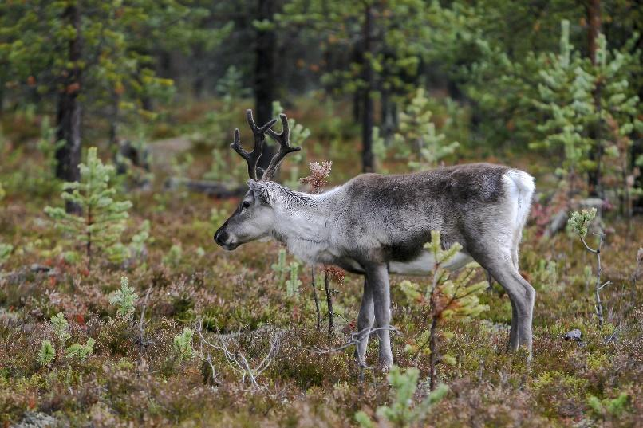

WENDESDAY: Sustainability and circular economy is the best-known practical solution to wicked problems

objectives: understanding sustainable development, understanding the importance of stopping overconsumption based on all thinking, understanding the unavoidability of circular economy thinking, understanding the link between circular economy and biodiversity, to know the most effective ways in circular economy.
learning outcomes: practical exercises for schools to learn about the circular economy, testing your lifestyle.

9.00-10.30 Sustainability and Agenda 2030, introduction, and discussion
- testing the lifestyle online, individual work,
- sea level raising, workshop.
10.30–10.50 coffee break
10.50-13.00 Moving from the linear to the circular economy.
- introduction
- circular city and how it works, workshop

13.00–14.00 lunch
14.00-15.30 Practices for schools, workshops
- Simon the Showoff
- “What has been asked.”

15.30-16.00 Reflection of the day

THURSDAY: Take the future in your hands, skills needed for good choices

objectives: understanding that future skills can be developed and thus influence one's future, future professions, the importance of one's own choices, stopping to look at one's own life, practicing good negotiation skills, busting myths, active citizenship.

learning outcomes: how can I implement a future camp in my own school and convert it for my own use

9.00–10.30 Future guidance, how to learn and teach future skills at school, first part of future camp
- what are the future skills?
- future camp, workshop: 2-3 first working stations
10.30–10.50 coffee break if needed
10.50–13.00 Future camp, workshop, 2-3 last workstations, 15-20 minutes each,
- skills bingo,
- vote for the future,
- statements about your personal life,
- futures skills,
- professions of the future,
- posters for better life
13.00-14.00 lunc
14.00–16.00 How to make compromises and destroy the myths we all have,
- MythBusters, workshop
- four words method, workshop
- active citizenship

FRIDAY: “What a wonderful world…” towards better future

objectives: the importance of biodiversity loss, the reality of environmental anxiety, especially for young people, finding hope. Finnish curriculum and how it supports students welfare
learning outcomes: getting to know and using learning methods that awaken hope and bring joy

9.00–10.30 Biodiversity loss, introduction,
- the success of species in the face of changes in the environment, species cards, worksho
10.30–10.50 coffee break
10.50–13.00 Sustainable lifestyle helps with climate anxiety and other difficult emotions caused by global warming, introduction of research done
- Exhibition of good news and innovations, workshop

13.00–14.00 lunch
14.00-16.00 school visit to the brand-new school Kaarre near the hotel https://www.lekolar.fi/kalusteet-sisustusratkaisut/referenssit/koulureferenssit/koulukeskus-kaarre-ivalo/
https://peda.net/inari/inarin-kunna-koulut/ivalon-lukio

SATURDAY: “Love the problem”, feedback and planning next steps

objectives: gain the courage to face different kinds of problems, the importance of art in thinking about the future, the importance of networking and feedback,
learning outcomes: creating functional networks, using social media, giving feedback to the course trainer and administrator

9.00-10.00 How to solve the problems.
- Snowball method, challenge method

10.00- 10.30 Art as a tool for better future,
- participants' outputs and thoughts during the week

10.30-11.30 Identification of common project topics and the formation of cooperation networks, feedback

11.30-12.00 Farewell coffee and certificates

